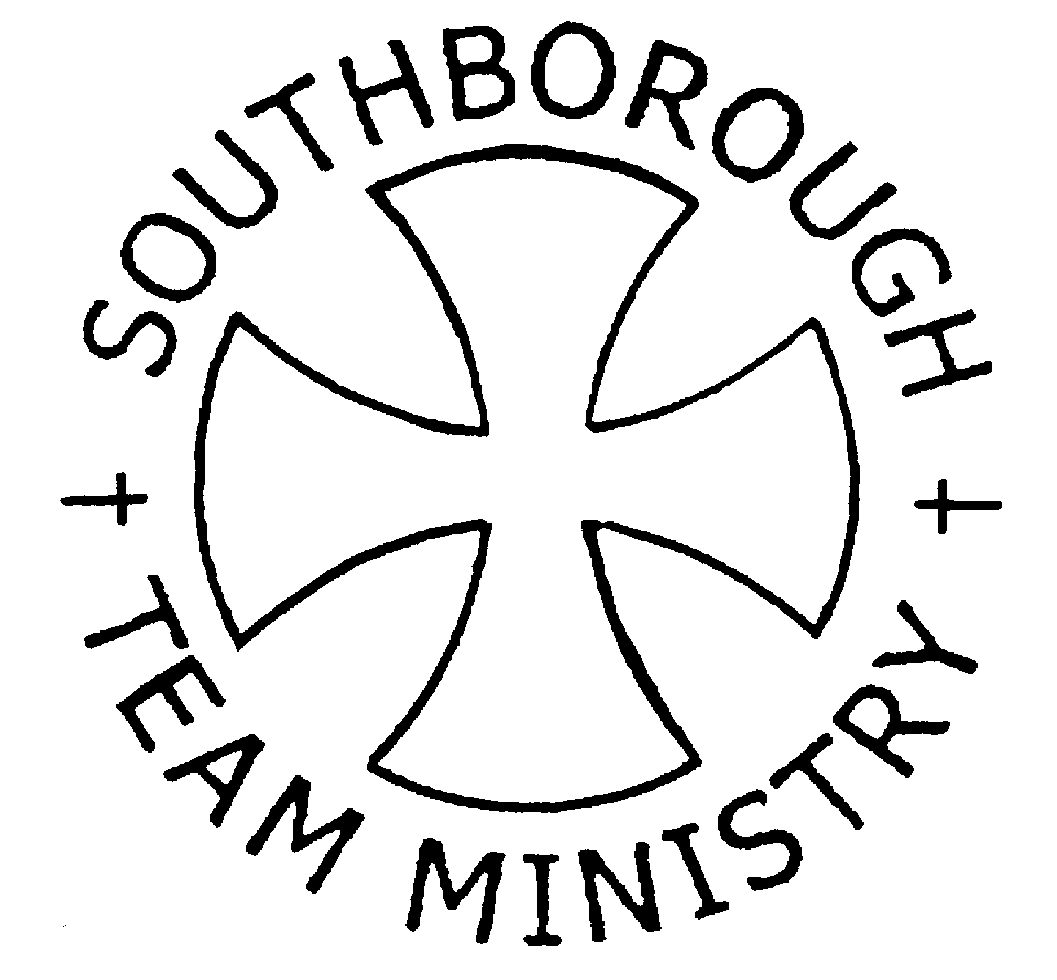St Peter & Christ Church, Southborough; St Matthew, High Brooms & S Lawrence, Bidborough
THE SOUTHBOROUGH TEAM MINISTRY

ANNUAL REGISTRATION AND MEDICAL INFORMATION FORM

Parents/Guardians – please read and complete the following sections

Full name of Child:

Home Address:

Post Code:
Date of Birth:

Child’s Mobile Number:
Parent's E-Mail:

Medical details of the Child

Name and Address of Doctor:

Telephone Number:
National Health Number: (if known)

If the answer to the following questions is YES, please give details overleaf: (Please delete)
1. Has the above named child ever been actively sensitive to penicillin? YES/NO
2. Does he/she suffer from any allergy? YES/NO
3. Does he/she carry any medication that needs to be taken regularly? YES/NO
4. Does he/she suffer from a condition or illness requiring regular treatment? YES/NO
5. Is there any activity that your child should not be allowed to participate in? YES/NO
Photographs
I give my permission for photographs and video recordings to be taken of my child when engaging in church activities and potentially published as follows: (please tick as appropriate)
 On the church website
 On Facebook (aged 13+)
 In Church or during church activities, eg. Collages, posters

Consent
I agree that the above named child may take part in activities organised by any of the churches within the Southborough Team Ministry including any organised trips or one to one mentoring meetings. I understand that while involved he/she will be under the control and care of the group leader and/or other adults approved by the PCC and that while the staff in charge of the group will take all reasonable care of the children they cannot necessarily be held responsible for any loss, damage or injury suffered by my child during or as a result of the activity.

I give my permission for my child to be contacted by: (please tick as appropriate)
□ | Telephone | □ E-Mail
□ | Text Message | □ Social Media
I understand that this form applies to all groups and activities that above named child attends. I give my permission for this form to be copied and given to appropriate group leader (s).
I understand that during the Friday youth drop in, young people are allowed to come and go and we cannot take responsibility for young people outside the church premises.

In the event of illness or an accident requiring emergency hospital treatment, I authorise the leader (s) to give consent to treatment. NB: Where possible you will always be contacted immediately and your consent sought.

Signed:
Date:

Name:
Tel Number (home):

Relationship to the child Tel Number (mobile):

This form will be retained and reviewed annually. Please notify Children/Youth Minister IN WRITING any changes in these details.

